Q-spider Date: 08-08-2026
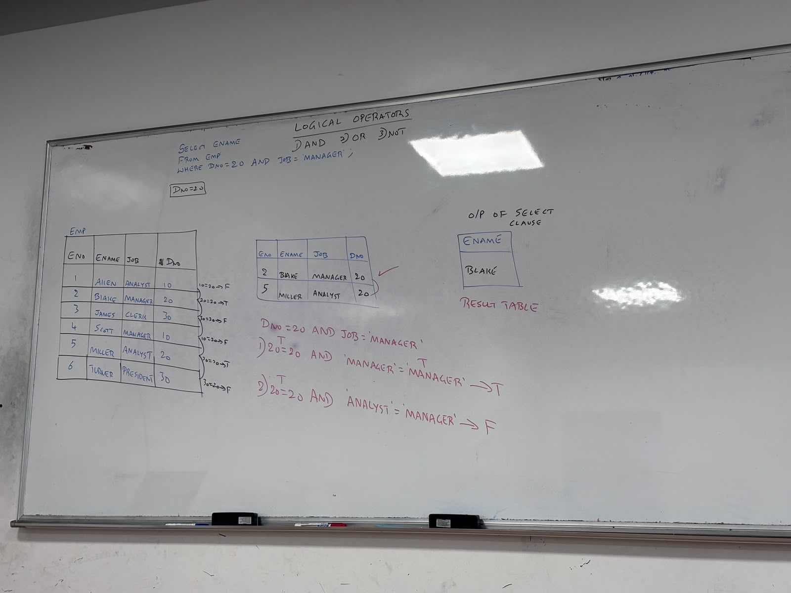
Q1. WAQTD Details of the employee, department no 20, as a manager
ANS>> SELECT * FROM EMP
WHERE DEPTNO = 20 AND JOB = ‘MANAGER’;
Q2. WAQTD NAME, DEPARTMENT NO AND SALARY OF THE EMPLOYEE WORKING IN DEPARTMENT NO 10 AND EARNING A SALARY LESS THAN 3000
ANS>> SELECT ENAME ,SAL, SEPATNO
FROM EMP
WHERE DEPTNO = 10 AND SAL <3000;
Q3. WAQTD NAME AND SAL OF THE EMPLOYEE IF THE EMPLOYEE ENTERS THE SALARY MORE THAN 1250 BUT LESS THAN 3000
ANS>> SELECT ENAME, SAL
FROM EMP
WHERE SAL>1250 AND SAL <3000;
Q4. WAQTD NAME AND HIRE DATE IF EMPLOYEE IS HIRED AFTER 1985 BUT BEFORE 1989
ANS>> SELECT ENAME, HIRDATE
FROM EMP
WHERE HIREDATE >31-DEC-1985 AND HIREDATE <01-JAN-1989;

OR
ONE OF THE CONDITION IS STSFIDE THAN THE ANS IS TRUE
Q5. WAQTD DETAILS OF THE EMPLOYEES WORKING IN DEPARTMENT 10 OR 20
ANS>> SELECT * FROM
WHERE DEPTNO=10 OR DEPTNO=20;
Q6. WAQTD DETAILS OF THE EMPLOYEES WORKING IN DEPARTMENT 30 OR 50
ANS>> SELECT * FROM EMP
WHERE DEPTNO=30 OR DEPTNO=50;
Q7. WAQTD NAME AND JOB OF THE EMPLOYEE IF THE EMPLOYEE IS WORKING AS MANAGER OR SALESMAN
ANS>> SELECT NAME,JOB FROM EMP
WHERE JOB= ‘MANAGER’ OR JOB = ‘SALESMAN’;
Q8. WAQTD NAME, JOB, DEPATMENT NO OF THE EMPLOYEES WORKING AS A MANAGER DEPATMENT NO 10 OR 30
ANS>> SELECT NAME, JOB, DEPTNO
FROM EMP
WHERE JOB=’MANAGER’ AND (DEPTNO=10 OR DEPTNO = 30);
Q9. WAQTD DETAILS OF THE EMPLOYEES WORKING IN DEPATMENT 10 OR 20 OR 30 AS A CLERK
ANS>> SELECT * FROM EMP
WHERE JOB= ‘CLERK’ AND (DEPTNO=10 OR DEPTNO= 20 OR DEPTNO= 30);
- Q10. WAQTD NAME,JOB, DEPTMENT NO, SALARY OF THE EMPLOYEES WORKING AS SALESMAN OR CLERK 10 OR 30 AND ERNING SALARY MORE THEN 1800
ANS>> SELECT NAME,JOB,DEPTNO,SAL
FROM EMP
WHERE (JOB =’CLERK’ OR JOB =’SALESMAN’) AND (DEPTNO=10 OR DEPTNO= 30) AND SAL>1800;
NOT
Q12. WAQTD DETAILS OF THE EMPLOYEE EXCEPT OF MANAGER
ANS>> SELECT *
FROM EMP
WHERE JOB NOT =’MANAGER’;
Q12. WAQTD DETAILS OF THE EMPLOYEE EXCEPT OF MANAGER
ANS>> SELECT *
FROM EMP
WHERE JOB! =’MANAGER’;
SPECIAL OPRATERS

- IN
- NOT IN
- BETWEEN
- NOT BETWEEN
- IS
- IS NOT
- LIKE
- NOT LIKE
IN ==. IT IS A MULTI-VALUED OPERATOR WHICH CAN ACCEPT MULTIPLE VALUES EXCEPT IN RHS
IN OPERATOR RETURNS TRUE IF ANY ONE OF THE VALUE IS SATISFIDE THE VALUE IN THE RHS
SYANTAX => COLUMN_NAME/EXPRESION IN (V1,V2,V3--------VN);
Q1. WAQTD DETAILS OF THE EMPLOYEE DEPARTMENT NO 20,30 OR 40
ANS=>
SELECT * FROM EMP
WHERE DEPTNO IN(20,30,40);

Q2. WAQTD NAME AND DEPATMENT NO OF THE EMPLOYEE WORKING IN DEPATMENT 30,40
ANS SELECT ENAME,DEPTNO
FROM EMP
WHERE DEPTNO IN(30,40);
Q3. WAQTD DETAILS OF THE EMPLOYEES WORKING AS MANAGER OR SALESMAN OR ANALYST
ANS SELECT *
FROM EMP
WHERE JOB IN (‘MANAGER ’, ’ SALESMAN ',’ ANALYST ’);
Q4. WAQTD ENO, ENAME OR SALARY OF EMPLOYEE WHO IS EMPLOYEE 7920 OR 7893 AND GETTING SALARY MORE THEN 925
ANS SELECT ENO,ENAME,SAL
FROM EMP
WHERE ENO IN (7902,7839) AND SAL > 3000;
__________________________________________________________________________________________
NOT IN IT IS SEMELAR TO IN OPERATOR, INSTEAD OF SELECTING THE VALUE ITS REJECTING THE VALUE
SYNTAX COLUMN_NAME/EXPRESSION NOT IN (V1,V2……VN);

Q1. WAQTD NAME AND DEPARTMENT NO OF ALL THE EMPLOYEES EXPCEPT THE EMPLOYEE WORKING IN DEPARTMENT 10 OR 40
ANS SELECT ENAME, DEPTNO
FROM EMP
WHERE DEPTNO NOT IN(10,40);
Q2. WAQTD DETAILS OF THE EMPLOYEE WORKING IN 20 BUT NOT AS CLERK AND MANAGER
ANS SELECT *
FROM EMP
WHRE DEPTNO =20 AND JOB NOT IN (‘CLERK’, ‘MANAGER’);
IS OPERATORS ITS USED TO COMPARE ONLY WITH NULL; compare
SYANTAX COLUMN_NAME/EXPRASSION IS NULL;

Q1. WAQTD NAME AND COMM OF THE EMPLOYEE WHO DOS NOT GET COMM
ANS SELECT ENAME,COMM
FROM EMP
WHERE COMM IS NULL;
Q2. WAQTD NAME AND SAL OF THE EMPLOYEE WHO IS NOT GETTING SALARY
ANS SELECT ENAME, SAL
FROM EMP
WHRE SAL IS NULL;

Q3. WAQTD DETAILS OF THE EMPLOYEE WHO DOS’T REPORTING MANAGER
ANS SELECT *
FROM EMP
WHRE MGR IS NULL;
Q4. WAQTD NAME, SAL AND COMM OF THE EMPLOYEE IF EMPLOYEE DOS’T EARN BOTH SAL AND COMM
ANS SELECT ENAME, SAL, COMM
FROM EMP
WHERE SAL IS NULL AND COMM IS NULL;
IS NOT IS TO COMPARE VALUE WITH NOT NULL
SYNTAX COLUMN_NAME/EXPRESSION IS NOT NULL;

Q1. WAQTD NAME AND SAL OF THE EMPLOYEE WHO IS GATING THE SALARY
ANS SELECT ENAME, SAL
FROM EMP
WHERE SAL IS NOT NULL;
Q2. WAQTD NAME AND COMM OF THE EMPLOYEE WHO GETS THE COMMISSION
ANS SELECT ENAME, COMM
FROM EMP
WHERE COMM IS NOT NULL;
Q3. WAQTD DETAILS OF THE EMPLOYEE WHO IS HAVING A REPORTING MANAGER
ANS SELECT *
FROM EMP
WHERE MGR IS NOT NULL;
Q4. WAQTD DETAILS OF THE EMPLOYEE IS THE EMPLOYEE DOS’T EARN SALARY BUT GETS SALARY
ANS SELECT *
FROM EMP
WHERE SALARY IS NOT NULL AND COMM IS NULL;

BETWEEN WHEN AVER WE HAVE RANGE OF VALUE
WE CAN’T CHANGE INTER THE RANGAES
BETWEEN INCLUDE THE RANGES
SYNTAX COLUMN_NAME/EXPRESSION BETWEEN LOWER_RANGE (>=) AND HIGHER_RANGE (<=) ;

Q1. WAQTD DETAILS OF THE EMPLOYEE WHOS EARNING SALARY 2000 AND 3000
ANSSELECT * FROM EMP
WHERE SAL BETWEEN 1000 AND 3000;
Q2. WAQTD DETAILS OF EMPLOYEES EARNING SALARY THE RANGE 1000 TO 3000
ANS SELECT * FROM EMP WHERE SAL BETWEEN 1000 AND 3000;

Q3. WAQTD NAME AND SALARY OF EMPLOYEE IF THE EMPLOYEE ERANNING SALARY BETWEEN 1250 TO 3000;
ANS=> SELECT ENAME, SAL
FROM EMP
WHERE SAL BETWEEN 1251 AND 2999;
Q4. WAQTD DETAILS OF THE EMPLOYEES HIRED BETWEEN 85 TO 90
ANS SELECT *
FROM EMP
WHERE HIREDATE BETWEEN 01-01-1986 AND 31-12-1989;

NOT BETWEEN IT’S SIMILAR TO BETWEEN OPERATOR INSTEAD OF SELECTING THE RANGE IT’S REJECT THE RANGE OF VALUES
SYNTAX COLUMN_NAME/EXPRESSION NOT BETWEEN LOWER_RANGE (>=) AND HIGHER_RANGE (<=) ;

Q1. WAQTD NAME AND SALARY OF THE EMPLOYEE IF THE EMPLOYEE NOT EARNING THE SALARY IN THE RANGE OF 1250 TO 3000;
ANSSELECT ENAME, SAL FROM EMP WHERE SAL NOT BETWEEN 1250 AND 3000;
Q2. WAQTD DETAILS OF THE EMPLOYEE NOT HIRED BETWEEN 1980 TO 1985
ANS SELECT * FROM EMP WHERE HIREDATE NOT BETWEEN 01-01-1981 AND 31-12-1984;

LIKE OPERATOR IS USED TO PATTERN MATCH
SYNTAX COLUMN_NAME/EXPRESSION LIKE ‘’PATTERN TO MATCH’;

TO ACHIEVE PATTERN MATCHING HER WE USED SPECIAL CHARACTERS % AND _
% PERCENTILE PERCENTIL IS A SPECIAL CHARACTER WHICH IS USED TO PATTERN MATCH
PERCENTILE ACCEPT ANY CHARACTER, ANY NUMBER OF CHARACTER SOME TIME NOT A CHARACTER
_ UNDERSCORE IS A SPECIAL CHARACTER WHICH IS USED TO PATTERN MATCHING
CAN ACCEPT ANY CHARACTER AT ONE TIME ONLY

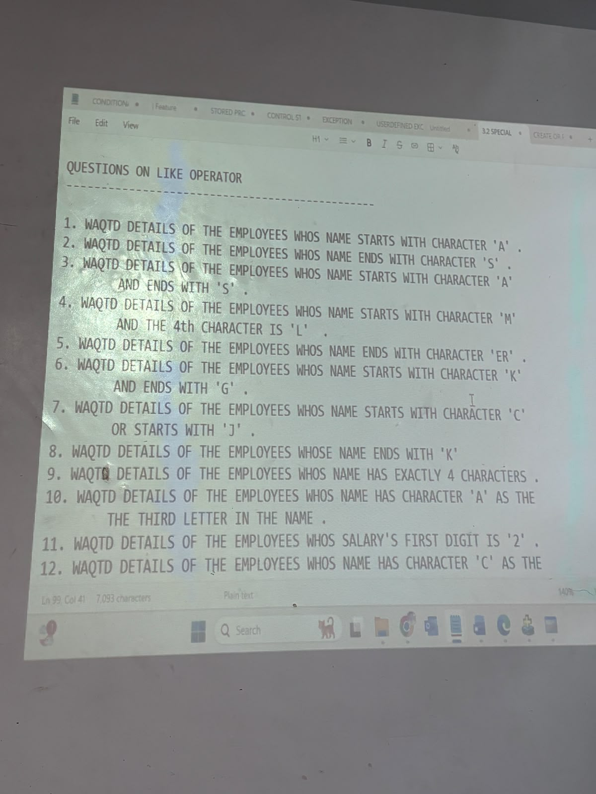 | - SELECT * FROM EMP WHERE ENAME LIKE ‘A%’;  - SELECT * FROM EMP WHERE ENAME LIKE ‘%S’;  - SELECT * FROM EMP WHERE ENAME LIKE ‘A%S’;  - SELECT * FROM EMP WHERE ENAME LIKE ‘M__L%’;  - SELECTC * FROM EMP WHERE ENAME LIKE ‘%ER’;  - SELECT * FROM EMP WHERE ENAME LIKE ‘K%G’;  - SELECT * FROM EMP WHERE ENAME LIKE ‘C%’ OR ENAME LIKE ‘%J’;  - SELECT * FROM EMP WHERE ENAME LIKE ‘%K’;  - SELECT * FROM EMP WHERE ENAME LIKE ‘____’;  - SELECT * FROM EMP WHERE ENAME LIKE ‘___A%’;  - SELECT * FROM EMP WHERE SAL LIKE ‘2%’;  - SELECT * FROM EMP WHERE ENAME LIKE ‘_C%T’;

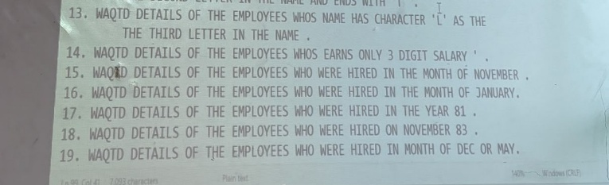 | - SELECT * FROM EMP WHERE ENAME LIKE ‘__L%’;  - SELECT * FROM EMP WHERE SAL LIKE ‘___’;  - SELECT * FROM EMP WHERE HIREDATE LIKE ‘NOVEMBER’ AND ‘JANUARY’;  - SELECT * FROM EMP WHERE HIREDATE LIKE ‘%1981’;  - SELECT * FROM EMP WHERE HIREDATE LIKE ‘%NOV%1983’;  - SELECT * FROM EMP WHERE HIREDATE LIKE ‘DEC’ AND ‘MAY’;  - SELECT * FROM EMP WHERE SAL LIKE ‘50%’;
NOT LIKE ITS SEMILAR TO LIKE OPERATOR INSTEAD OF SELECTING THE PERTTAINF ITS REJECT THE PARTTERN TO MUCH
SYNTAX COL_NAME/EXPRATION NOT LIKE ‘PATTERN TO MATCH’

FUCTION FUCTION ARE A BLOCK OF CODE OR THE LIST OF INSTRUCTION WHICH IS USED TO PERFORM A SPECIFIC TASK
COMPONANTS OF FUCTION
- FUCTION NAME
- NUMBERS OF ORGUMENTS
- RETUREN TYPE
SINGLE ROW SINGLE ROW FUCTION EXICUTE ROW BY ROW
SINGLE ROW ROW FUCTION TACKES ONE INPUT AND PROCESS AND EXCUTE AND GENRATE OUT-PUT, THEN IT WILL TACK NEXT INPUT AND SO ON.
IF YOU PUSH N NUMBER OF INPUT IN SIGLE ROW FUCTION IT WILL GENRATE N NUMBER OF OUT PUT.

MULTI ROW FUCTION
- MULTI ROW FUCTION EXICUT GROUP BY GROUP
- MULTI ROW FUCTION TACKES ALL THE INPUTS AT A ONE TIME AND COMBAINES IT AND PROCESS AND EXICUTE AND GENRATE ONE OUT PUT
- IF YOU PUSH THE N NUMBER OF INPUT IN MULTI ROW FUCTION IT WILL GIVE ONE OUT PUT ONLY

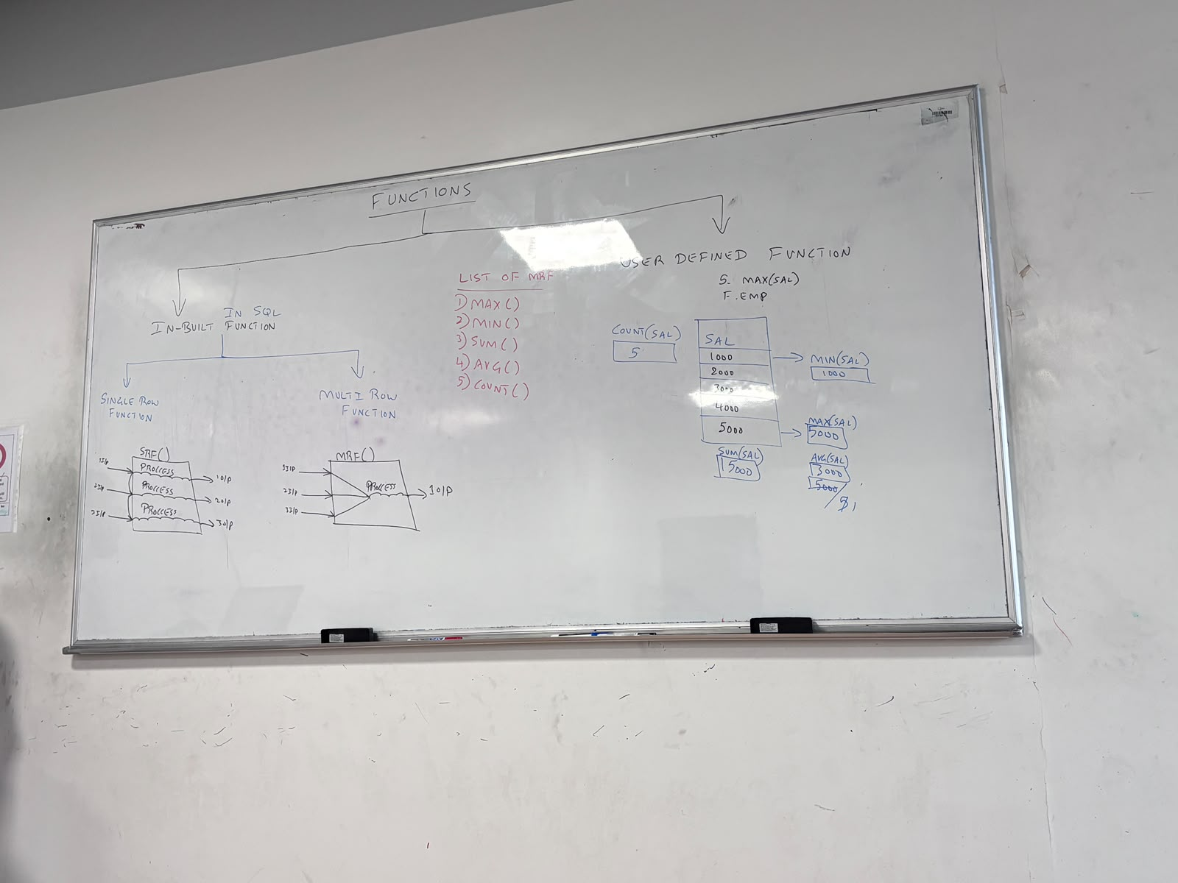
NOTE
- MULTI ROW FUNCTION CAN ACCEPT ONLY ONE ARGUMENT: COLUMN NAME AND EXPRESSION
- MULTI ROW FUCTION IGNORE THE NULL VALUES
WE CAN'T USE A MULTI ROW FUNCTION IN WHERE CLAUSE
- COUNT IS THE ONLY ONE FUNCTION WHICH CAN ACCEPT * AS ASTRICK ARGUMENT
SYNTAX MRF (COLUMN/EXPRESSION );

Q1. WAQTD MAXIMUM SALARY GIVEN TO MANAGER
ANS SELECT MAX(SAL)
FROM EMP
WHERE JOB=’MANAGER’;

Q2. WAQTD TOTAL SALARY OF DIPATMENT NUMBER 10
ANS SELECT SUM(SAL)
FROM EMP
WHERE DEPTNO=10;

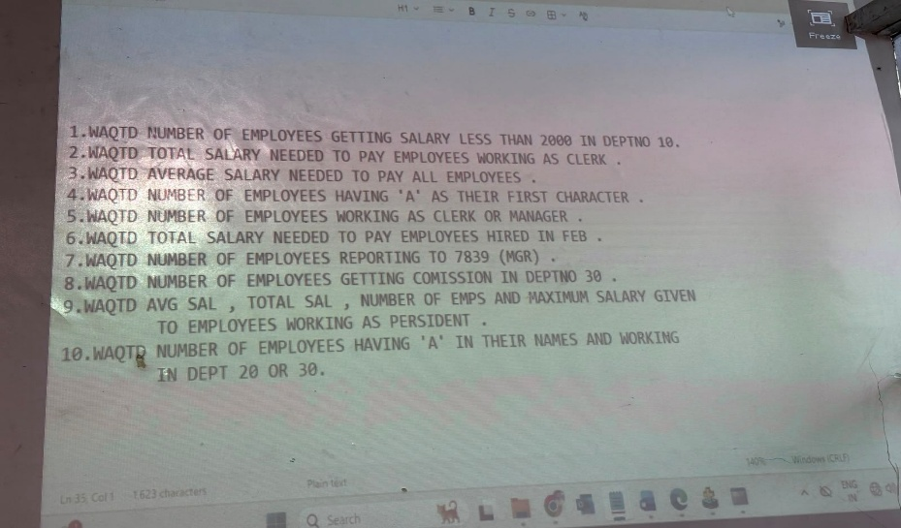 | - SELECT MIN(SAL) FROM EMP WHERE DEPTID =10;  - SELECT SUM (SAL) FROM EMP WHERE JOB =’CLERK’;  - SELECT AVG(SAL) FROM EMP ;  - SELECT COUNT(ENAME) FROM EMP WHERE ENAME LIKE ‘A%’;  - SELECT * COUNT(JOB) FROM EMP WHERE JOB=’CLERK’ AND JOB = ‘MANNAGER’;  - SELECT SUM(SAL) FROM EMP WHERE HIREDATE LIKE ‘%FEB%’;  - SELECT COUNT(MGR) FROM EMP WHERE MGR =7839;  - SELECT COUNT (COMM) FROM EMP WHERE DEPTID=30;  - SELECT AVG(SAL),SUM(SAL),COUNT(SAL),MAX(SAL) FROM EMP WHERE JOB =’PRESIDENT’;  - SELECT COUNT(*) FROM EMP WHERE DEPTID IN (30,40) AND ENAME LIKE ‘%A%’;

